J06. NSW Bookstall Company Art Series [n.l. 1905]

Pu New South Wales Bookstall Company
Pr In Australia, coloured half-tone
F Picture filling much of card with title in narrow white margin along base (if H) or R.H. margin (if V). Colour of rocks in background generally reddish-purple (R) or grey-green (G).
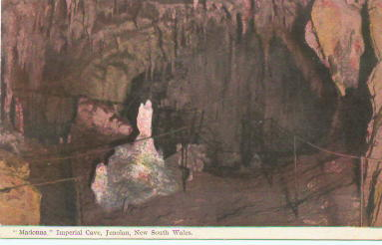
J06.1 "Madonna," Imperial Cave, Jenolan, New South Wales H (R,G) [pm.5 Sep.1905]
J06.2 "The Willows," Jenolan Caves, New South Wales V (R,G) s.n.a. Kerry 81.4. [pm.4 Sep.1905]
J06.3 "Lot's Wife," Imperial Cave, Jenolan, New South Wales V (R,G) [pm.6 Jun.1905]
J06.4 "The Snow Room," Jenolan Caves, New South Wales V (R,G) Note mis-spelling of 'Show Room' ; s.n.a. Kerry 01.9. [pm.27 Jan.1905]
J06.5 Carlotta Arch, Jenolan Caves, New South Wales V (R) [pm.20 Jul.1905]
J06.6 "Broken Columns," Lucas Cave, Jenolan, New South Wales V (R) [pm.24 Jul.1905]
J06.7 "The Mystery," Jenolan Caves, New South Wales V (R) (s.n.a. Kerry 77.4) [pm.21 Aug.1905]

